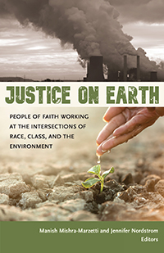
A Common Read invites participants to read and discuss the same book in a given period. A Common Read can build community in our county by giving diverse people a shared experience, shared language, and a basis for deep, meaningful conversations.
Discussion group to begin in October.
Join the conversation.

http://uupoconos.org/
The 2018-19 UUA Common Read

This highly anticipated anthology presents a powerful and penetrating look at environmental justice from some of the key thinkers and activists in Unitarian Universalism today. Fourteen activist ministers and lay leaders apply a keen intersectional analysis to the environmental crisis, revealing ways that capitalism, white supremacy, patriarchy, and other systems of oppression intersect with and contribute to ecological devastation. They also explore how spiritual practices, congregational organizing, and progressive theology can inform faith-based justice work in the twenty-first century.
These prophetic voices, from a wide range of perspectives, reveal new approaches and opportunities for more holistic, accountable, and connected justice efforts. Each essay is accompanied by suggested ways to take the next steps for further learning and action.
----------------------------------------------------------------------------------------------------------------------------Books ordered of 10 of more at a reduced price of $14.40 each. Regular price $18.00
Please contact 570 730-4122 and leave a message or email barbee_h51@yahoo.com if you are interested in ordering the book or being part of a discussion group.
Open to the public. All are welcome. Social Justice in action!
UUFP is committed to providing a welcoming space to all without regard to race, color, religion, age, sex, sexual orientation, gender identity, national origin, disability or protected veteran status.

